**VANTIQ Blueprint**  
VANTIQ.com



**Field Service Management – Quick Setup**

**Last Revision: November 1, 2018**

Installation

Before beginning these are the following pre-requisites to activating this application.

1. A Modelo namespace. Preferably one that is empty.
2. API Keys for Google Maps services Directions, TimeZone, GeoCode and Distance, Twilio SMS services and SMTP credentials to send email with.
3. A basic understanding of VANTIQ is required.

Obtain the latest version of the VANTIQ blueprint in a download called “VANTIQ - Field Service Management”. This will be contain the documentation and the projects contents in the form of a zip file “bp_fsm.zip” and an additional JSON file “NotificationTemplates.json” which contains the contents of the database Type for customer email/sms notifications.

If you do not have these two files please contact VANTIQ for additional inquiry.

1. Log into your Namespace
2. Click on the blue Projects button and select Import  
   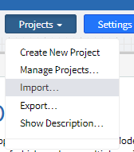
3. This will open the Import Projects or Data window:   
   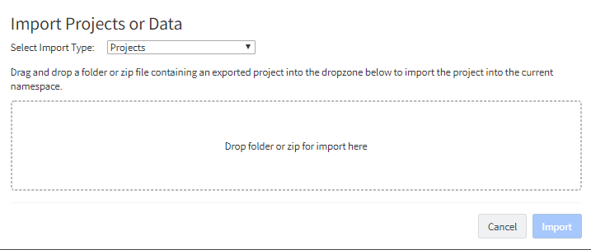
4. Drag and drop the bp_fsm directory or zip file into the dotted box.
5. A long list of project elements will show up, at the bottom of this list is an Import button.  
   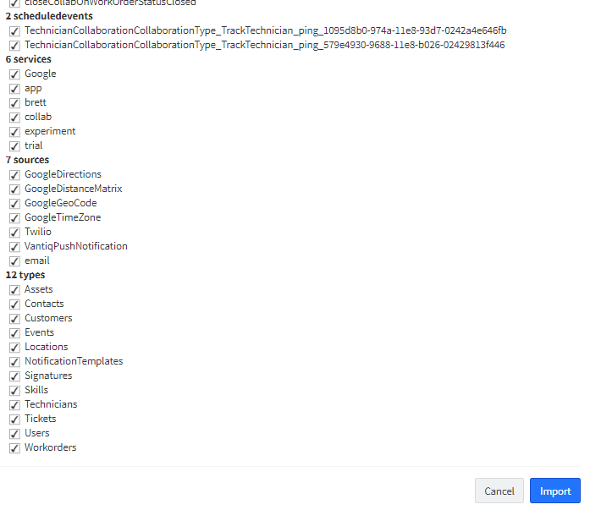
6. Once the import is complete reload your web browser.
7. Open the Import Projects or Data a second time.
8. Change the Import Type to “Data” and the Data Type to “NotificationTemplates”
9. Drag and drop the “NotificationTemplates.json” into the dotted box and click Import to complete.
10. Click on the “Development” button
11. Open the “README” project for further instructions.
12. Make sure to follow the instructions to fill to provide your API keys.

Data Population

Once the project is fully setup and ready to use you can begin adding data. Before new Tickets and Work Orders can be added it is necessary to populate your database. At least one of the following is required:

1. User
2. Customer
3. Location
4. Contact
5. Technician
6. Skill
7. Asset (not required but recommended)

Once at least one record was added for each Tickets and then Work Orders can be created.

### Running the Application

Running the application requires the VANTIQ mobile applications. Technicians access the application from the VANTIQ mobile application. iPhone and Android users can install the VANTIQ application from the App Store or Play Store.

More Information

VANTIQ blueprints are designed to be modified. A full detailed document of all the development components is available that will simplify the customization and adoption of this project.